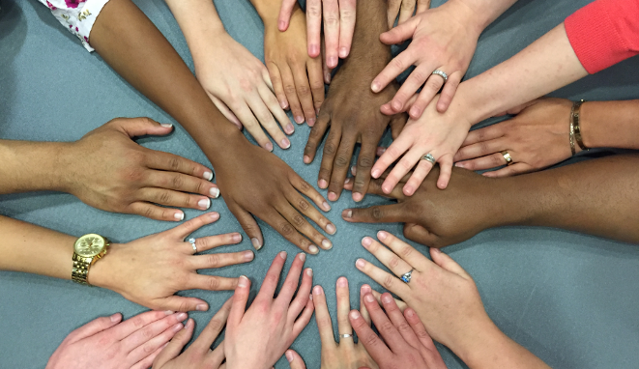
3rd Annual

Diversity, Equity, & Inclusion Symposium
The Intersections of Religion, Spirituality,
and Medicine

Thursday, September 14th, 2023
8am – 1pm
Hybrid – CHP Rangos and Zoom

PEDIATRIC GRAND ROUNDS
Muslim Experiences as a Critical Lens
in the “Problem” of Religion in Medicine
8:00am – 9:15am
Presented by
Aasim Padela, MD, MSC, FACEP
Professor with Tenure of Emergency Medicine, Bioethics and the Medical Humanities at Medical College of Wisconsin.
https://pitt.zoom.us/j/99545812135
Passcode: 904133

SESSIONS
Please register separately per session

Spirituality, Health, and the Wellness of
Black Minds, Bodies, and Souls
9:30am - 10:30am
Presented by
Stephanie Boddie, MSW, PhD
Associate Professor of Church and Community Ministries, Baylor University
Click here to register / CME code: DUTLOV
Righteousness, Risk, and Repentance: Jewish Responses for When Bad Things Happen to ‘Good’ Patients
11:00am - 11:45am.
Presented by
Jonathan Weinkle, MD, FAAP, FACP
Medical Director, PA Studies Program, Chatham University. Squirrel Hill Health Center.
Click here to register / CME code: SOXQES

PANEL DISCUSSION
12:00pm – 1:00pm
Lunch will be provided in-person.
Part 1: Living with One’s Faith in the Medical Space
Presented by
Janet Digber-Williams MD Danyah Hasan, MS, CCLS
Andrew McCormick, MD, FAAP Tahniat Syed, MD MPH
Rameshwari Tumuluru, PhD Michael Moritz, MD

Part 2: ReligYinz: Mapping Religious Pittsburgh
Presented by
Rachel Kranson, PhD, Benjamin Gordon, PhD, Aaron Brenner
Department of Religious Studies, University of Pittsburgh.
CLICK HERE TO REGISTER / CME Code: JUWKUP

Sponsored By

The Office of Diversity, Equity, and Inclusion
The Office of Education
Department of Pediatrics University of Pittsburgh

Contact

Loreta Matheo: loreta.matheo@chp.edu
Noel Spears: spearsnb@upmc.edu
Jess Hammill: hammillj2@upmc.edu

“This activity is approved for the following credit: AMA PRA Category 1 Credit™, ANCC, ASWB, and AAPA Category 1 CME. Other health care professionals will receive a certificate of attendance confirming the number of contact hours commensurate with the extent of participation in this activity.”

